**Project 1:**

**Blinking of LED(Light Emitting Diode )**

**Description**: In this project, we will do how a led light blinking.

**Required Hardware:**

· Arduino Uno.

· Breadboard.

· Jumper wire.

· LED

· Resistor.

· USB type A/B.

**LED**:

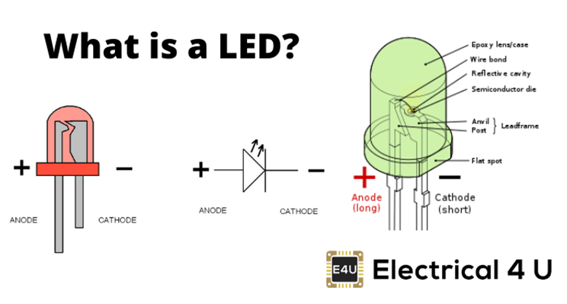

**PIN OF LED:**

LED refers to Light Emitting Diode include two pins:

1. Cathode(-) pin- must be connected to GND (0V)

2. Anode(+) pin - is used to control LEDs state

**Specifications:**

1. 5mm Round Standard Directory

2. Forward current: 30mA

3. Forward Voltage: 1.8V - 2.4V

4. Reverse Voltage: 5V

5. Operating Temperature: -30 to 85 degree celsius

**Circuit Diagram:**

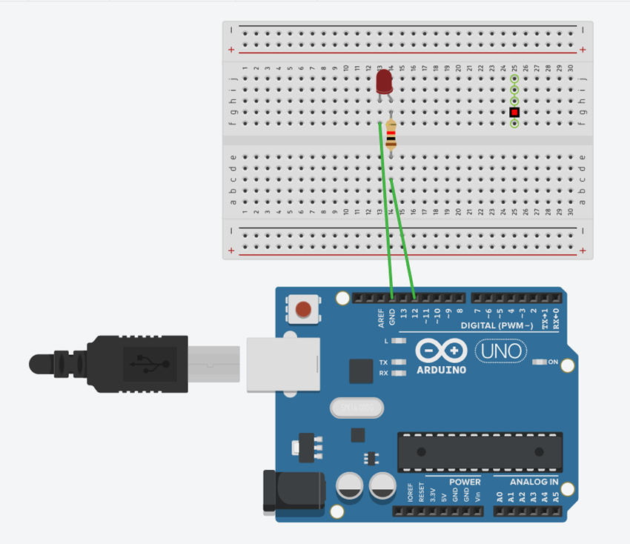

**Arduino and LED Connection:**

* LED cathode(-) pin to GND
* LED anode(+) pin to 330 ohm resistor to digital pin 12.

**Code:**

| int pin=12;  void setup()  {  pinMode(pin, OUTPUT);  }  void loop()  {  digitalWrite(pin, HIGH);  delay(1000); // Wait for 1000 millisecond(s)  digitalWrite(pin, LOW);  delay(1000); // Wait for 1000 millisecond(s)  } |
| --- |